On This Date – HMCS STAR Naval Chronology
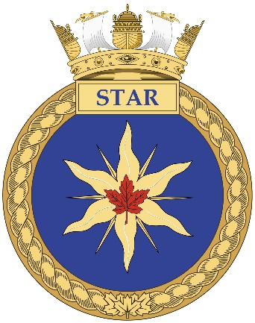
The focus of this chronology is primarily the Hamilton Naval Reserve in all its iterations but pan-Naval events are also included. It is a work in progress. Some entries have been expanded whist others are minimal. Suggestions for corrections or additions are welcomed. Acknowledgement would be appreciated when information from this document is republished.
See also http://hamiltonnaval.ca/ or https://www.facebook.com/hamiltonnavalheritage/.
LCdr (Ret’d) Neil S. Bell January 2019 info@hamiltonnaval.ca
Contents
January 2
February 5
March 9
April 11
May 14
June 18
July 20
August 21
September 24
October 26
November 28
December 30

January
01 January 1946 RCNVR & RCNR merged into RCN(R). End of wavy stripes.

4 January 1945 Lt(P) Donald Sheppard, who was posted to STAR in 1948 as Staff Officer (Administration) for Commanding Officer Naval Divisions, shoots down two Japanese Nakajima Ki-43s (Japanese army equivalent to the Zero) while escorting planes attacking oil refineries on Sumatra. He went on to claim another three aircraft thus becoming the only Canadian to become an ace flying the Corsair.
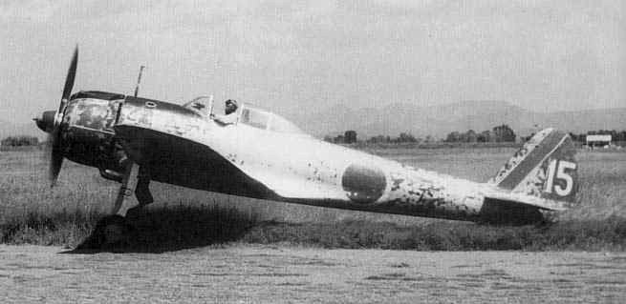

16 January 1945 Lieutenant Bernard John Kennedy, RCNVR of HMCS STAR and assigned to 763 Squadron, HMS Nightjar, RNAS Inskip, was killed when on a night navigation exercise over the Irish Sea from RNAS Inskip in Lancashire, the Grumman Avenger Mk II JZ390 he was flying hit the Great Gully above Wastwater Screes in The Lake District of Cumbria, killing him and his crew of two.

19 January 1957 2 Avengers from VC-920 in Toronto (to which STAR contributed personnel) were flying over Lake Erie when Avenger 86001, code 907 lost engine power and ditched on the ice 15 miles south of Port Stanley. The 2 crew sat in the dinghy on the ice till rescued by an American Naval Reserve HUP 2 from Grosse Isle, Michigan, the nearest RCAF helicopter being 275 miles away at Trenton, and taken to London.
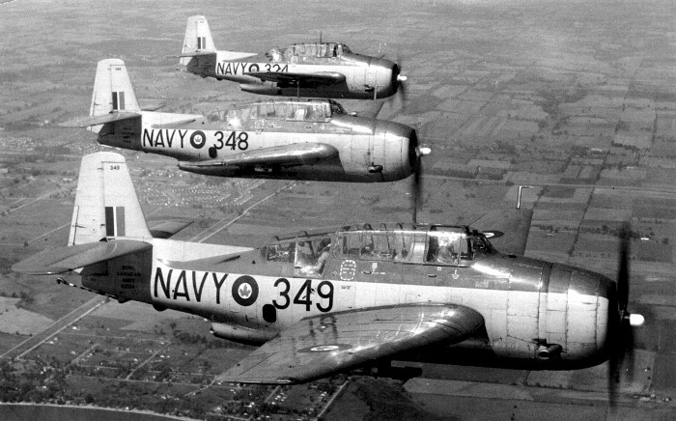

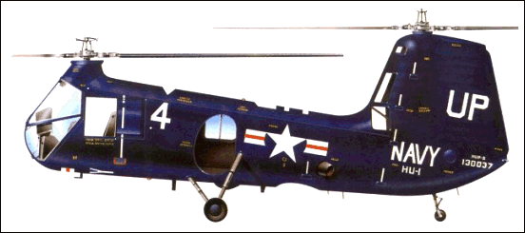
24 January 1948 former naval barracks (Cabot Macaroni Company) on Stuart Street destroyed by fire. The building had been owned by Nello Pataracchia, who became a naturalized Canadian in 1923 but was arrested in 1940 as an enemy alien and interned at Camp Petawawa and Camp Fredericton. While interned the Canadian government contracted with Cabot Macaroni Company to supply pasta products to internees at Petawawa.
26 January 1955 Female members of the RCN(R) may enter the RCN as regular members
27 January 1942 The Seagoing Officers Club, later to be known as the Crow’s Nest Officers Club, was founded in Saint John’s, NL, the western station of the North Atlantic Run/(later known as) Newfy to ‘Derry Run, by Captain Rollo Mainguy, Captain “D” of St. John’s, with the help of Colonel Leonard Outerbridge DSO, and his wife, Dorothy, who secured space in the old Butler Building near the waterfront. The club was located on the vacant top floor of the building and reached by a rickety but iconic set of 59 steps.
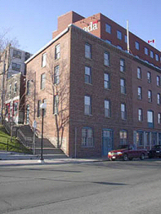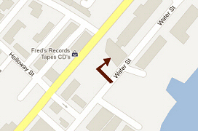

28 January 1944 Steward Dirk Van Ooyen, V-8608, RCNVR of HMCS STAR was missing following a collision between HMCS MAHONE, a Bangor class minesweeper, and the merchant SS Fort Townsend off Louisburg

30 January 1973 HMCS STAR Dive Team is called to assist in the recovery of a car from Desjardin’s Canal following a fatal car accident on Highway #403.
31 January 1862 Under the authority of the Militia Act of 1855, a Hamilton Naval Company was established. The 1863 Militia list shows Captain Thomas Harbottle & Lieutenant George P. Malcomson, with seniority of 31 January 1862, of the Hamilton Naval Company, #7 Military District.
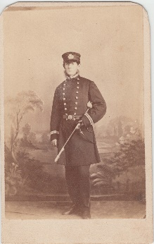
31 January 1923 Order in Council #139 authorizes the formation of “a Force of not more than 1,000 volunteer officers and men to be called the Canadian Naval Volunteer Reserve (Royal prefix came later) while Order in Council #140 cancels the Royal Naval Canadian Volunteer Reserve.
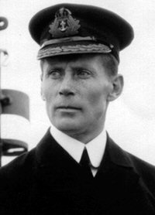
RAdm Walter Hose, the “Father of the Naval Reserve”

February
1 February 1943 Five acres of Eastwood Park sold for a new home for HMCS STAR. The city purchased the site in 1886 as a site for a new wharf and then converted into the North End Park by filling in the water’s edge with refuse and covering it with top soil.
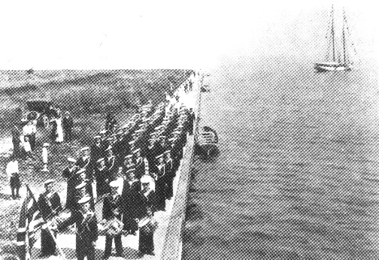

1 February 1956 HMCS PATRIOT commissioned as FOND (Flag Officer Naval Divisions)
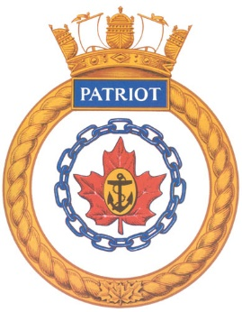
1 February 1968 The RCN becomes Maritime Command of the new Canadian Armed Forces. Green uniform introduced over the next few years.
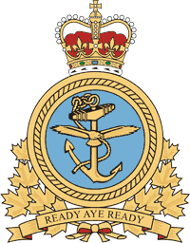
03 February 1968 SLt William John BOLES, formerly a communicator at STAR and serving with VU-32 at SHEARWATER, was killed when his CS-2F Tracker #1543 crashed during an instrument landing approach to CFB DOWNSVIEW.
06 February 1810 Sailors from HMS STARR a 16 gun ship of the MERLIN class, form part of a Naval Brigade that establishes gun batteries to bombard the capital of Guadaloupe, the last French colony in the West Indies. The surrender of Guadaloupe markedly diminishes the slave trade, made illegal by Britain in 1807. In 1847, participants are eligible to apply for the Naval General Service Medal with the clasp, Guadaloupe, and STAR received the battle honour Guadaloupe.
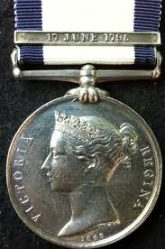

06 February 1943 HMCS LOUISBURG, corvette, torpedoed and sunk off Cape Tenes near Oran in Mediterranean by Italian aircraft while escorting convoy KMF-8 from Gibraltar to Bone, 42 lost plus 5 RN of 98. 36-15N 00-15E
Leading Signalman Cecil Floyd Anderson, V-8276, RCNVR, son of Floyd & Galdys Anderson of Port Colborne, died of injuries in Muttapha General Hospital in Algiers and is buried in Dely Ibrahim War Cemetery there.

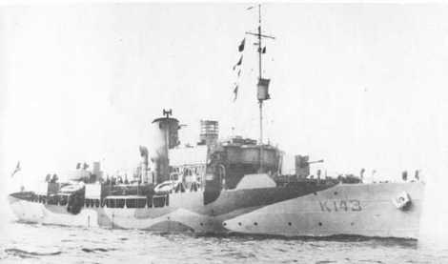

10 February 1942 HMCS SPIKENARD, K-198, corvette, while escorting convoy SC.67, torpedoed & sunk approx 400 nm north-west of of Ireland by U-136, 57 lost, 8 survivors. 56-10N 21-07W
  - Lieutenant Robert Alexander Hughes, RCNVR
  - Leading Stoker Cyril Frederick Kitchen, A-1571, RCNR
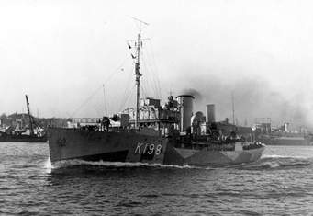

14 February 1945 MTBS 459, 461, 462, 465 & 466 of 29th MTB Flotilla destroyed by explosion and fire in Ostend, Belgium, possibly due to a discarded cigarette igniting fuel accidentally pumped into the harbour. Seven British boats also lost with 26 Canadians & 35 British sailors killed
  - Stoker Charles Wesley Long, V-55625, RCNVR - HMC MTB 461
  - Able Seaman William Robert Park, V-48704, RCNVR - HMC MTB 465
15 February 1965 New Canadian Maple Leaf flag replaces both the White Ensign & the Blue Ensign used as a Jack
16 February 1942 Lieutenant Ralph Crossley Ripley, O-62320, RCNVR of HMCS STAR is lost when the patrol launch HMS FANLING was sunk in the Banka Strait, Sumatra by a Japanese cruiser during the evacuation of Singapore. Ripley had previously survived the sinking of the PRINCE OF WALES on 10 December 1941.

16 February 1945 The River Class frigate HMCS SAINT JOHN sinks U-309 in the Moray Firth, Scotland. A/Lt James Peter Wright is awarded the Distinguished Service Cross “For services in action against an enemy U-Boat in February 1945”. He was appointed to STAR in 1950 and served as XO between 1954 & 1958.

22 February 1945 The corvette TRENTONIAN is torpedoed and sunk by U-1004 south of Falmouth England with the loss of six men. Her CO, LCdr Colin S. GLASSCO, who had been in command for only twenty-three days, was appointed CO of STAR three months later.
24 February 1809 Seamen & marines from HMS STARR, a 16 gun ship of the MERLIN class, participate in the capture of Martinique from the French during the Napoleonic Wars. Participants later awarded the Naval General Service Medal with the clasp MARTINIQUE and STARR awarded the battle honour MARTINIQUE.
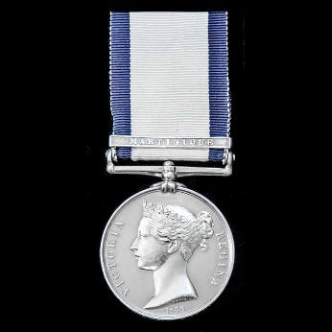

March
6 March 1944 The corvette CHILLIWACK, whose mast is on STAR’s quarterdeck, shares in the sinking of the Type VII-C U-boat, U-744.

14 March 1941 The merchant ship, SS Western Chief, a former WWI US Navy cargo ship of 5,759 GRT, a straggler from convoy SC24 from Halifax to Liverpool, was torpedoed & sunk by Italian submarine EMO 250 nmi south of Iceland. Western Chief was carrying 7,400 tons of steel. Ordinary Seaman Arthur Neil Dearden, V-8376, RCNVR, of Hamilton, presumably onboard as a gunner, was among the 23 casualties from the crew of 43.
EMO, which had been operating from the Italian Betasom (Bordeaux Sommergibile) submarine base at Bordeaux, was sunk in November of 1942 in the Mediterranean.
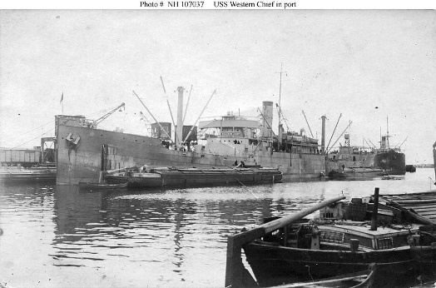
SS WESTERN CHIEF as US Navy cargo ship ID-3161 in 1919
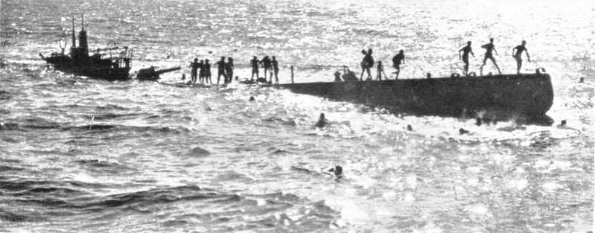
EMO sinking 10 November 1942

15 March 1923 Lt Ralph H. Yeates appointed CO of Hamilton Half Company of RCNVR. Montreal Company’s CO, Lt Frank Meade, was appointed the day previously, making STAR the second oldest Naval Reserve Division.

17 March 1945 HMCS GUYSBOROUGH, a VTE engined Bangor minesweeper, while sailing from Horta in the Azores to Plymouth, was torpedoed & sunk in Bay of Biscay off Ushant by U.868. Even though she was streaming CAT gear, she was hit in the stern by a GNAT torpedo and when she didn’t sink, torpedoed again. Of the fifty-one lost, only two were killed in the initial torpedo explosion and forty-nine died from exposure in the nineteen hours it took for recue to arrive. 46-43N 09-20W
Leading Stoker Jack Gardner Berryman, V-16905, MID, RCNVR - Posthumous Mention in Dispatches “For outstanding courage, resolution and devotion to duty when their ship was sunk”

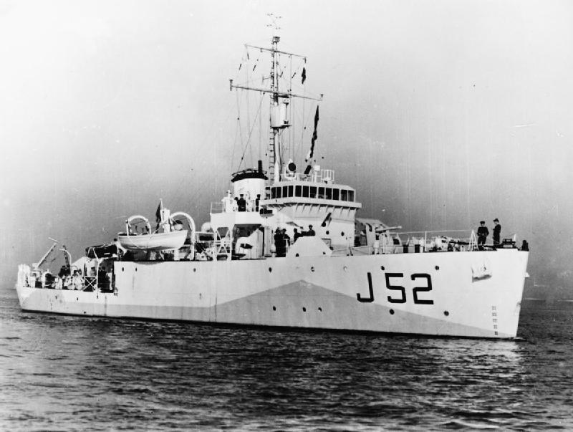

19 March 1943 The American steamer SS Matthew Luckenbach left Convoy HX-229 (37 ships from New York & Halifax) to make its own way to England and was torpedoed by U-527 and then by U-523. HMCS COLUMBIA salvaged the Matthew Luckenbach and took her into port after she had twice been abandoned. Lieutenant (E) John Alfred Savory, RCNVR, of Lumsden Avenue, Hamilton received the OBE. “ During the salvage of the SS Mathhew Luckenbach, Lieutenant Savory took complete charge in the engine room and by his ability and enthusiasm obtained the fullest support of the merchant ship’s engine room staff.”

28 March 1944 LCdr Reginald “Cowboy” Jackson, having served as CO of the corvette KENOGAMI and the Bangor minesweeper SAULT STE. MARIE for thirty-one months during the heart of the Battle of the Atlantic, is appointed CO of HMCS STAR.

28 March 1953 Commanding Officer Naval Divisions (COND) moves to STAR
30 March 1972 Black Tot Day – the end of the rum ration in the RCN. A mock funeral was held at HMCS STAR and a small casket with a rum bottle was ceremonially buried at sea.

April
1 April 1941 At the beginning of the Second World War, the German navy had several “Pocket battleships” and heavy cruisers as well as armed merchant ships that they used as independent raiders. These raiders relied on supply ships to keep them going. Early in 1941, four German supply ships, the MÜNCHEN (5,619 tons, North German Lloyd Company), HERMONTHIS (4,833 tons, Hamburg-American Line), LEIPZIG (5,898 tons, North German Lloyd) & MONSERRATE (5,578 tons, Hamburg-American Line) were in Callao, Peru, awaiting an opportunity to make their way back to German. The Canadian armed merchant cruiser HMCS PRINCE HENRY entered the neutral harbour, ostensibly to fuel, and then left to just over the horizon. When intercepted by PRINCE HENRY, both ships fired scuttling charges and set themselves on fire to avoid capture. PRINCE HENRY laid alongside HERMONTHIS and sent a boarding party over to attempt to extinguish the flames and save what they could. Leading Seaman Ernie Smedley, a member of that boarding party, managed to “liberate” this flag from her masthead. Many years later, Ernie Smedley, an Inspector in the Hamilton Police Department in civilian life, was also the Executive Officer of HMCS STAR.
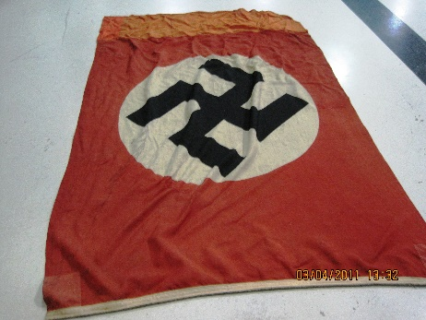

8 April 1941 The Flower Class corvette, CHILLIWACK, whose mast is on STAR’s quarterdeck, is commissioned in Vancouver. During her short career she escorted thirty-eight Atlantic convoys and shared in the sinking of U-356 & U-744. She was paid off in 1945 and scrapped in Hamilton in 1946.

13 April 1941 Lieutenant(E) Victor Roque Bussereau, RCNVR of HMCS STAR is lost when the armed merchant cruiser HMS RAJPUTANA, armed merchant cruiser, was torpedoed and sunk 13 April 1941 by U-108, while patrolling the Strait of Denmark west of Reykjavik. HMS RAJPUTANA was a P&O passenger liner of 16,568 Gross Register tons on the England to India run, having carried such notables at Mahatma Gandhi & Colonel T.E.Lawrence (Lawrence of Arabia). She was requisitioned on 4 September 1939, armed with eight six inch guns but without armour, and commissioned as an armed merchant cruiser on 16 December 1939. Having escorted Convoy HX-117, she was torpedoed and sunk 13 April 1941 by U-108, in the Strait of Denmark west of Reykjavik. Forty of the crew were lost and 283 survivors were picked up by the destroyer LEGION, having survived twelve hours in open boats.

16 April 1945 HMCS ESQUIMALT, Bangor minesweeper, torpedoed & sunk in less than four minutes 5 miles off Chebucto Head near Sambro Island by U-190 (surrendered 12 May 45 at Bay Bulls, Nfld, periscope in Crow’s Nest Officers’ Club, sunk after war by NOOTKA & NEW LISKEARD), 44 lost (many to exposure after being in the water for more than six hours) & 26 survivors. 44-28N 63-10W
  - Leading Stores Assistant David Anderson Hughes, V-8384, RCNVR
23 April 2016 Admiralty Ball at LIUNA Station celebrates 100th anniversary of RNCVR recruiting in Hamilton & 75th anniversary of commissioning of HMCS STAR
24 April 1943 First piling laid for Building Two, new STAR building. Angus Macdonald, Minister of National Defence for Naval Service, Captain E.R. Brock, RCNVR, Commanding Officer Reserve Divisions & CO LCdr John McFetrick
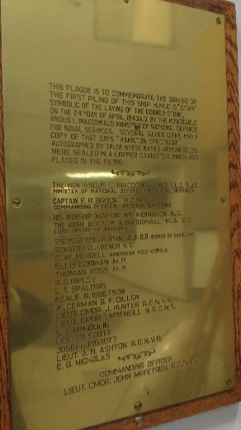
27 – 29 April 1967 USS Portage visits

29 April 1944 HMCS ATHABASKAN torpedoed & sunk by German torpedo boats T-24 northeast of Ouessant, 128 lost, 83 taken prisoner and 44 rescued by HAIDA. 48-32N 04-32W
- The following STAR sailors were killed in the sinking:
  - Able Seaman Albert Ernest Allison, V-8402, RCNVR - MPD
  - Stoker Thomas George McCarroll, V-39522, RCNVR - MPD
  - Engine Room Artificer 3rd Class Walter McGiffen Love, V-8030, RCNVR - MPD
  - Able Seaman Eric Robertshaw, V-8634, RCNVR - KIA
  - Signalman William George Stewart, V-8866, RCNVR – MPD
- The following were rescued by HAIDA:
  - Leading Coder William Hayes, V-8722, RCNVR
  - Leading Seaman John F. Kane, V-8971, RCNVR
  - Telegraphist William M. Martin, V-45798, RCNVR
- The following were taken as Prisoners of War by the Germans:
  - Signalman William E. Connolly, V-40271, RCNVR
  - AB John B. Holwell, V-8875, RCNVR

May
1 May 1953 VC 920 Squadron established at HMCS YORK to train Naval Reserve pilots. It flew the North American Harvard , Grumman Avenger & Beechcraft Expeditor. They operated out of RCAF Station Downsview, where the outline of an aircraft carrier landing deck was painted on the runway. The detachment at STAR trained at Downsview and also at RCAF Station Hamilton (Mount Hope) with 424 Reserve Squadron, RCAF, with a Swordfish and two Seafires as training aircraft. The squadron was disbanded on 31 March 1964. STAR donated a Seafire propeller to Canadian Warplane Heritage and received a two bladed wooden propeller, probably from an Avro Anson Mk II equipped with Jacob L6 engines, in return.
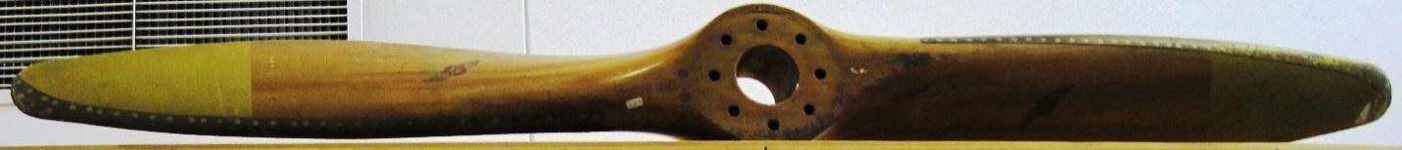
4 May 1910 Naval Service Act creates Naval Service of Canada with RAdm Charles Kingsmill as Director Naval Service – the birthday of the RCN. Warships to fly the Canadian Blue Ensign
5 May 1985 On the occasion of the 75th Anniversary of the RCN, HMCS STAR receives the Freedom of the City of Hamilton. A tree is planted at Hamilton City Hall. The third iteration of the tree is now at Pier Four Park overlooking the water.
5 May 2013 the former RCN jack became the Naval Ensign
06 May 1814 HMS STAR takes part in the successful raid on Oswego, New York.
Yeo’s new frigates HMS PRINCE REGENT & PRINCESS CHARLOTTE having been launched and equipped at Kingston, and lacking troops denied him by Prevost to attack Sackett’s Harbour, he decides to attack Oswego before Chauncey can ready his new ships at Sackett’s Harbour: the frigate SUPERIOR, launched 3 May & the corvette GENERAL PIKE, still on the ways
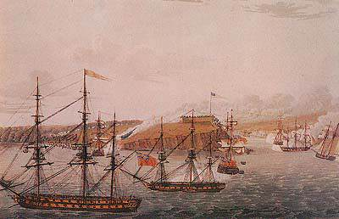

07 May 1944 HMCS VALLEYFIELD, frigate, having escorted westbound convoy ONM-234 from Londonderry, torpedoed & sunk by U-548 40 miles s/e of Cape Race, 125 of 159 lost, many to exposure after the sinking. 46-03N 52-24W
  - Stoker Gordon William Barefoot, V-54372, RCNVR
  - Ordinary Seaman Jeffery Alfred Long, V-62261, RCNVR
  - Able Seaman Frank Louis Windsor, V-8662, RCNVR
  - Stoker Ist Class Stanley Carson Tapson, V-54278, RCNVR, survived
GODWIN, Donald Harold, Sub-Lieutenant - Mention in Despatches - RCNVR / HMCS Valleyfield - Awarded as per Canada Gazette of 20 January 1945 and London Gazette of 5 December 1944. Home: Hamilton, Ontario. GODWIN. Donald Harold, 0-27612, S/Lt(Temp) [?] RCNVR MID~[20.1.45] "For services and brave rescue work when HMCS VALLEYFIELD was sunk”
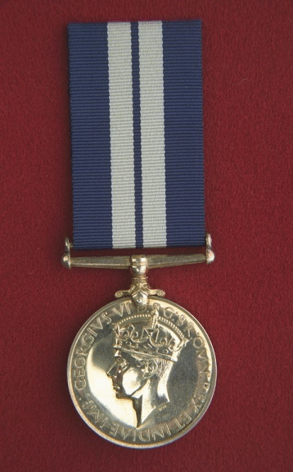
13 May 1945 The German Type IXC/40 submarine , U-889, was on her first war patrol when the war ended. Ordered to surface and surrender, she was escorted to Shelburne Nova Scotia and, until December of 1945, served as HMCS U-889. How the helmet from her came to be in our collection is unknown.
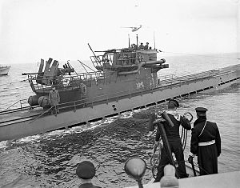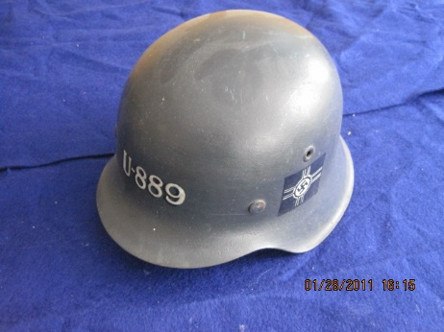

18 May 1914 Privy Council Order 1313 authorizes the formation of the Royal Naval Canadian Volunteer Reserve to enlist men to serve in the RCN or with the RN. An RNCVR recruiting committee in Hamilton begins work. Despite the recruiting difficulties, by the end of the war the RNCVR had grown from 3 Officers and 40 ratings (May 1914) to 745 Officers and 6,613 ratings. In addition to manning the variety of Canadian coastal ships, the two submarines and shore establishments, Canadian Reservists crewed trawlers and drifters in British home waters, Gibraltar and West Africa. At the same time, the strength of the Royal Canadian Navy grew to 391 Officers and 1,080 ratings and more than 600 Canadians had enlisted directly in the Royal Navy and Royal Naval Volunteer Reserve.
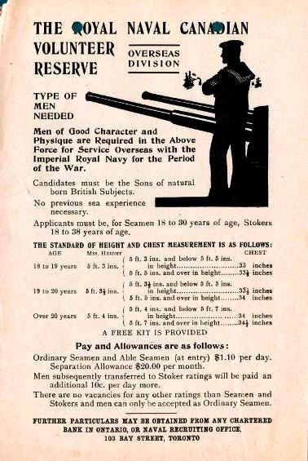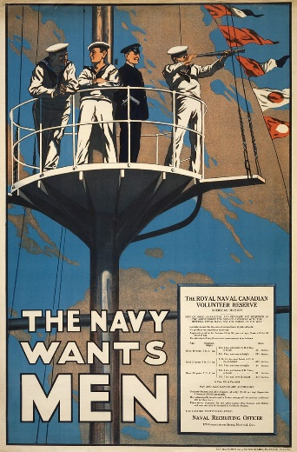

19 May 1855 As a result of the withdrawal of much of the British military presence in Canada during the Crimean War (1853-1856) the 1855 Militia Act authorizes the formation of a “Volunteer Marine Company” at Hamilton.
- XXIII. A Volunteer Marine Company may be formed at each of the following places, Kingston, Cobourg, Toronto, Hamilton, Port Stanley, Dunnville and Oakville : each Company to consist of a Captain, a Lieutenant and fifty men : and a Commodore of Provincial Marine may be appointed to command the whole and to rank as a Lieutenant Colonel of Militia ; Captains in the Provincial Marine shall rank as Majors in the Militia, and Lieutenants as Captains in the same.
- XXIV. The said Marine Companies shall be armed in such manner as the Commander in Chief shall direct, and shall V)e trained and drilled as well to the use of small arms, as in the management of gun-boats and vessels and the working of great guns on board vessels.
20 May 2016 New RCN badge approved. The pale blue background of the former Maritime Command badge is replaced by dark blue, the eagle is removed (since the RCN has no organic air arm), the anchor reverts to the traditional flat shape and the motto, Ready Aye Ready in English and Toujours là, toujours prêts in French, is given by the Latin, Parati Vero Parati.
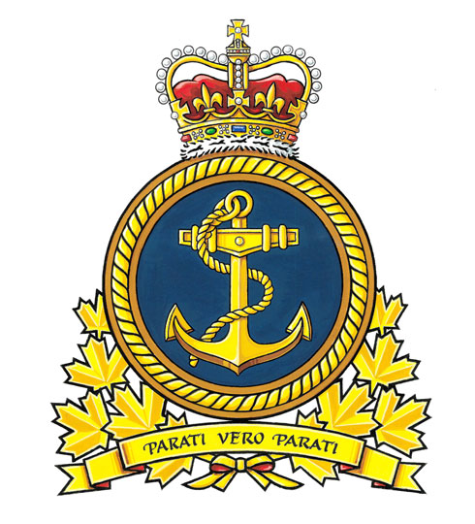
24 May 1943 Grand Admiral Karl Dönitz recalls U-boats from the North Atlantic, states “We had lost the Battle of the Atlantic”!
29 May 1652 STAR’s Battle Honour “DOVER” awarded as a result of the participation of Oliver Cromwell’s STAR, a 24 gun ship, in The Battle of Goodwin Sands during the First Anglo-Dutch War
End May 1963 HMCS HAIDA visits on her farewell Great Lakes cruise

June
1 June 1943 LCdr Isabel McNeill becomes the first women to command a commissioned ship in the British Empire when the WRCNS Training Establishment at Galt is commissioned as HMCS CONESTOGA
1 June 1952 RTEGL (Reserve Training Establishment Great Lakes), later Great Lakes Training Centre, opens at HMCS PATRIOT.

1 June 1954 Kitchener Tender to STAR established. LCDR J.R.H. Kirkpatrick RCN(R), later Captain, who was awarded the DSC “For undaunted courage, resolution and skill during a series of actions against enemy forces while serving in Light Coastal Craft” while Senior Officer of the 65th Canadian Motor Gun Boat Flotilla and CO of MTB-748, in command. Paid off 30 November 1964.
2 June 1866 Fenian Raids, Battle of Ridgeway, Hamilton Naval Company on duty at the powder magazine & drill shed but not engaged
6 -17 June 1944 During the Normandy landings, the Revenge Class battleship, RAMILLES, whose bell is on STAR’s quarterdeck, was involved in gunfire support of the landings on Sword Beach. In the course of this operation, she fired one thousand & two fifteen inch shells, the equivalent of one hundred twenty-five broadsides, thought to be the greatest single bombardment by any ship to that time.
11 June 2010 On This Date the “Executive Curl” was restored to the rank braiding of RCN officers. Introduced into the RN in 1856, the “Executive Curl”, or “Elliot’s Eye” was originally only for officers of the Executive Branch, but extended to engineers in 1915 and to all officers in 1918. The vast majority of navies world wide use a curl or some device above the top row of braid. The RCN lost the curl in 1968 upon unification.
15 June 1920 RNCVR disbanded
19 June 1943 Naval Order 2854 creates University Naval Training Divisions (UNTD). Approximately eight thousand are trained over the next twenty-five years till the program was ended with unification in 1968.
20 June 1911 Imperial Conference in London concludes. Agreement for vessels of the RCN to fly the White Ensign with the Canadian Blue Ensign as a jack
26 June 1959 Following the opening of the St. Lawrence Seaway, numerous Canadian & American warships tour the Great Lakes. These ships were in Hamilton:
Restigouche Class Destroyer Escorts – 5th Canadian Escort Squadron
- RESTIGOUCHE 257 June 1959
- KOOTENAY 258 Senior Officer for RY BRITANNIA 1959
- TERRA NOVA 259 June 1959
- GATINEAU 236
- ST CROIX 256 June 1959
Prestonian Class Frigates - part of 9th Canadian Escort Squadron
- BUCKINGHAM 314 June 1961?
- CAP DE LA MADELAINE 317
- LAUZON 332 June 1961?
28 June 1948 Fairmile Q-106 assigned as a tender to HMCS STAR and later renamed BEAVER.
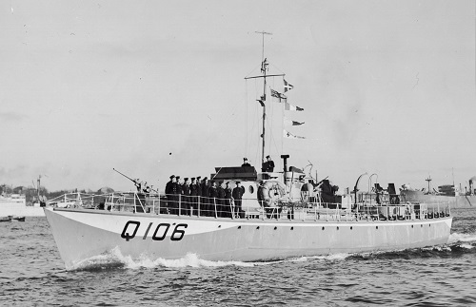

July
1 July 1985 In the 75th anniversary year of the RCN, Distinctive Environmental Uniforms (DEU) introduced for Canadian Armed Forces and issued over the next several years.
2 July 1935 Hamilton Half Company RCNVR moves to Wilson/Dominion Vinegar Works, 41 Stuart Street, between Bay & McNab
6 July 1941 the former American Town class destroyer USS KALK is commissioned as HMCS HAMILTON in Saint John, New Brunswick. The name has nothing to do with Hamilton, Ontario: she was named HAMILTON in the RN as a place name common to both the United Kingdom and the United States and the name was retained when she came to the RCN after the Hamilton River (renamed Churchill River in 1966) in Labrador

10 July 1949 HMCS PORTAGE visits
13-16 July 1959 Following the celebrations for the opening of the St. Lawrence Seaway, the Royal Yacht BRITANNIA arrives for a visit to Hamilton and berths at HMCS STAR. BRITANNIA’s ship’s badge now hangs over the wardroom bar and Royal portraits hang over the wardroom fireplace.
16 July 1947 Ordinary Seaman Richard Alan Appleyard, 5734-H, RCN of HMCS STAR killed when HMCS MICMAC collided with SS Yarmouth County off Sambro Head near Halifax, 5 dead, 15 injured, 5 missing presumed dead

19-22 July 1995 HMCS CORMORANT visits
22 July 1813 HMS LORD MELVILLE, later renamed HMS STAR, launched in Kingston, Ontario
25 July 1992 The Perry Class frigate USS SAMUEL ELLIOT MORRISON, FFG 13, visits. Sold to Turkey in 2002, she was extensively modernized and now operates as TCG GÖKOVA F-496.
27-28 July 2011 Oberon class submarine OLYMPUS, used as a training submarine, passes through Hamilton on her way to Marine Recycling in Port Colborne for scrapping pictures off submarine at Heddle dated 27 July 2011
31 July 1942 Women’s Royal Canadian Naval Service (WRCNS) founded

August
1 August 1964 Integration of the RCN, Army & RCAF
2-5 August 1967 HMCS THUNDER & FUNDY visit in conjunction with LYRA (Lake Yacht Racing Association) Centennial races
5/6 August, 1944 Only two Conspicuous Gallantry Medals were awarded to the RCN during the Second World War: one to CPO Max Bernays in HMCS ASSINIBOINE and the other to AB Michael Kerwin of HMCS HAIDA. In action with German forces, HAIDA had already fired over one thousand rounds of 4.7” ammunition and, after a break in the action but with the guns still extremely hot, a charge ignited in the right gun of “Y” mount before the breech was closed, engulfing the mount and the port side of the ship in flame from burning cordite and hydraulic oil. Two sailors were killed and eight wounded. Kerwin, himself partially blinded and wounded by splinters, rescued the gun trainer from the gun shield, both being badly burned in the process. “Y” gun was removed from HAIDA during her refit after the war but the site of the deed is HAIDA’s quarterdeck where the Squid mount presently is fitted.
6 August 1942 CERA class Donald Portree from Hamilton is awarded the DSM for his actions in fighting a fire during HMCS ASSINIBOINE’s sinking of U-210. A/CPO Max Bernays was awarded one of two Canadian Conspicuous Gallantry Medals during that action. There were seven other Hamiltonians serving in ASSINIBOINE during the action:
- PO Leonard F. Seager 3 Francis Street – captain of 3” AA gun mounted between funnels
- AB Gordon Almas 490 Wilson Street, Hamilton
- AB Bert Lindsay 11 Herkimer Street, Hamilton
- AB George Tuck 227 Mary Street, Hamilton
- AB James Hart 257 King William Street, Hamilton
- PO Edward Moore 31 Genesee Street, Mount Hamilton arm injury
- AB Arthur Moore 31 Genesee Street, Mount Hamilton

8 August 1813 US Warships HAMILTON & SCOURGE founder in a squall off Port Dalhousie, wrecks later acquired by the City of Hamilton
8-11 August 1975 HMCS NIPIGON visits

9 August 1963 HMCS HAIDA lands reserves & returns to Halifax

10 August 1813 Commodore Yeo’s squadron including LORD MELVILLE skirmish with Commodore Chauncey and the American schooners JULIA & GROWLER are captured. Yeo employs the two, renamed CONFIANCE & HAMILTON respectively, briefly but then turned them into transports as they were slow and unwieldly.

10-12 Aug 1967 Matchmaker III Squadron – USS ZELLARS, HNLMS ROTTERDAM & HMCS SAGUENAY
12 August 1814 Sailors from STAR march from Lake Ontario to Lake Erie and capture the American schooners, SOMERS & OHIO in a cutting-out expedition.
16 August 1911 King George V approves the title Royal Canadian Navy for the Naval Service of Canada. One hundred years later, Maritime Command of the Canadian Forces is renamed the Royal Canadian Navy
17 & 18 August 1866 Three Britomart Class gunboats, BRITOMART, CHERUB & HERON having arrived on the Great Lakes as a result of the Fenian Raids, HMS HERON visits Hamilton. There was a civic reception for the officers at the Royal Hotel followed by view of city from Mountain View Hotel on the escarpment. Then the ship embarked dignitaries for a sail in the harbour during which the 112 pound Armstrong gun was fired and a Congreve rocket set off before the ship returned to the McNab Street Wharf.

18 August 1967 COND moves to Halifax as Director Naval Reserves (DNR)
19 August 2011 OKANAGAN, paid off Oberon class submarines stops off in Hamilton on her way to Marine Recycling Corporation for scrapping

21 August 1944 HMCS ALBERNI, corvette, torpedoed & sunk in the English Channel off Isle of Wight at 50-18N, 00-51W. by Gnat from U-480, sank in less than 30 seconds, 59 lost & 31 survived & picked up by British MTBs. 50-18N 00-51W
  - Stoker 1st Class Donald Neil Garvey, V-75547, RCNVR
  - Stoker 1st Class Robert John Karns, V-52383, RCNVR
  - Leading Stoker Horace Edward Wilkinson, 22129, RCN

23-25 August 1959 Destroyer escorts HMC Ships GATINEAU, KOOTENAY, ST. CROIX, RESTIGOUCHE & TERRA NOVA & frigates CAP DE LA MADELAINE, LAUZON & BUCKINGHAM visit Hamilton preparatory to participating in a NATO Naval Review at the CNE.

23 August 1963 HMCS SIOUX & NOOTKA visit

24 August 1967 USS PROWESS AM-280, an Admirable Class minesweeper based at Buffalo for reserve training, visits

28 August 1942 Lt Hal Lawrence, later famous as the author of A Bloody War", "Tales of the North Atlantic" and "Victory at Sea", is awarded the DSC for his actions during the corvette OAKVILLE’s sinking of U-94 during which he and a PO were the only members of the boarding party to make it to the submarine where they were able to subdue the crew. Lawrence was posted to HMCS STAR in 1953 on the staff of Commanding Officer Naval Divisions.

30 Aug – 5 Sept 1967 HMCS KOOTENAY & NIPIGON visit.
30 August 2003 The former HMCS HAIDA arrives in Hamilton

September
3 September 1989 Captain Shane Antaya, RCAF, is killed when his CT-114 Tutor of the Snowbirds Demonstration Team, crashed during the CNE Airshow. STAR’s tender, Ville class tug CAVALIER, acts as picket at the crash site from 4 to 12 September.

3 September 2003 3 September designated Canadian Merchant Navy Day

6 September 1940 Sub Lieutenant Frederick Southam Ker, RCNVR, of HMCS STAR is lost in the sinking of HMS GODETIA, a British Flower Class corvette, while escorting Convoy OA-207 (Methil on Firth of Forth to Liverpool), was rammed and sunk 6 September, 1940, 3 nautical miles off Altacarry Head, North Channel at 55° 18’ N 05° 57’ W by merchant ship Marsa (convoy OA.209), neither showing any lights. 32 of 47 crew lost. On 4 September, GODETIA and HMCS ST. LAURENT (Lt H.S. Rayner) had picked up 90 survivors from SS Titan, sunk by U-47 (Kptlt Gunther Prien). Godetia was the first Flower Class corvette to be lost.

7 September 1944 Motor Mechanic Archibald B McPhail, V-42963, RCNVR of HMCS STAR died of burns received when Fairmile M/L 082 suffered a fuel explosion in the engine room while based at HMCS CHALEUR II, Quebec City, but possibly operating out of Gaspe.

9 September 2011 HMCS MONTREAL visits

10 September 1939 Canada declares war on Germany

10 September 1941 Signalmen Hugh Eugene Tobin from HMCS STAR is awarded the DSM as a result of his actions when part of a boarding party from the corvette HMCS CHAMBLY that boarded the German submarine U-501 off the south-east coast of Greenland. Despite the efforts of the boarding party, U-501 sank and a Canadian sailor was taken down with her. U-501 was the first U-boat sunk by the RCN.

10 September 2010 HMCS FREDERICTON visits

12-15 September 1814 HMS METEOR, the former HMS STARR rebuilt as a bomb vessel, takes part in the bombardment of Fort McHenry at Baltimore, Maryland. Some of “the bombs bursting in air” from the American National Anthem came from METEOR.

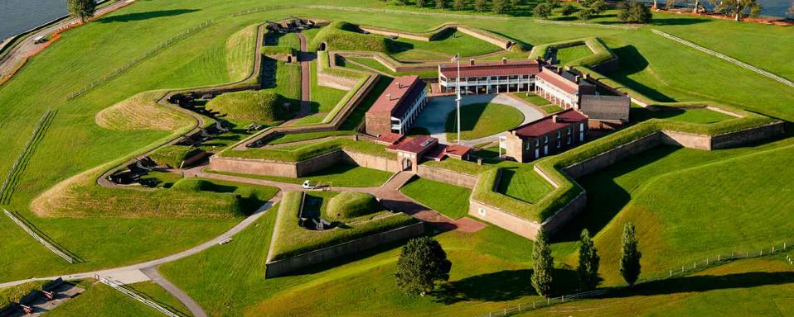

14 September 1942 HMCS OTTAWA, destroyer, while escorting convoy ON.127, torpedoed & sunk in North Atlantic approx 500 nm east of St. John’s by U-91, 113 or 114 lost, 69 survivors. 47-55N 43-37W
Signalman Walter James Crane, V-8330, RCNVR
Lieutenant Ian Stanley McLeod, RCNVR
Able Seaman Ernest Francis Taylor, V-8299, RCNVR
Able Seaman Thomas William Young, 3497, RCN

20 September 1943 HMCS ST. CROIX, destroyer, while escorting convoy ON.202, torpedoed & sunk by Gnat from U-305 south of Iceland, 147 lost overall (67 lost in initial sinking or exposure in the water & 80 of 81 rescued by HMS ITCHEN after 13 hours in the water were lost when she was sunk the next day). 57-30N 31-10W
Able Seaman David Bayford Rowell, V-8359, RCNVR

20 Sept 1948 USS EGRET & SEAGULL visit

20 September 2012 HMCS VILLE DE QUEBEC & USS HURRICANE visit to commemorate the War of 1812 Bicentennial

25 September 1996 Sod turning for new Building 40, Deputy Prime Minister Sheila Copps, KINGSTON, GLACE BAY & ANTICOSTI alongside

26 September 1942 Signalman Frank Hinchcliffe, V-8495, RCNVR of HMCS STAR was lost when the S.S. Boston, the Commodore’s ship of convoy RB-1, was torpedoed and sunk on
25 September 1942, 610 miles east-southeast of Cape Farewell by U-216, 47 survivors rescued by destroyer HMS VETERAN which was torpedoed & sunk the next day by U-404 with all hands.

27 September 1997 Opening Ceremony for Building 40, MND Art Eggleton

28 September 1813 LORD MELVILLE, later STAR, takes part in an engagement that came to be called The Burlington Races. The two squadrons meet off York and when WOLFE lost her main & mizzen topmasts, Yeo retired to the Head of the Lake. Chauncey in PIKE pursued with ROYAL GEORGE, LORD MELVILLE & BERESFORD screening their flagship. The squadron anchored in a gale off Burlington with springs on their cables and Chauncey thought better of it and retired up the lake.

29 September 1918 “C” Class destroyer STAR depth charged & sank German submarine UB-115 off the coast of England near Newcastle.

October
12-16 October 1995 HMCS ANTICOSTI visits
13 October 1973 CCGS PORTE DAUPHINE, commanded by Captain Archie Hodge, a long-time friend of STAR, discovers the wrecks of the War of 1812 warships, USS HAMILTON & SCOURGE, off Port Colborne.
14 October 1954 Cornerstone of Building One laid by RAdm Walter Hose, CBE. Hose was Director Naval Service and subsequently Chief of Naval Staff from 1920 till 1934. He was responsible for the creation of the Naval Reserve in 1923.
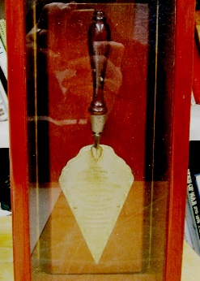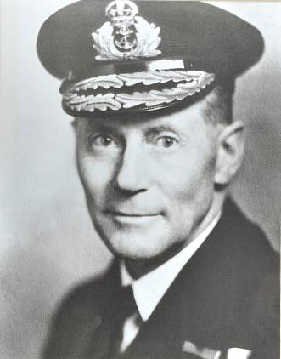

18 October 1940 HMCS BRAS D'OR presumed sunk in a storm in the Gulf of St Lawrence while on voyage from Clark City, PQ to Sydney, NS. All hands (30) lost.
  - Ordinary Seaman Walter Garnett Armes, V-8307, RCNVR
21 October 1805 The British fleet of twenty-seven ships of the line led by Vice Admiral of the White Horatio Lord Nelson, defeats a combined French & Spanish fleet of thirty-three ships of the line led by Admiral Pierre-Charles Villeneuve off Cape Trafalgar on the south-west coast of Spain. The French/Spanish fleet lost twenty-two ships but Lord Nelson was killed. The event has been commemorated throughout the Commonwealth as Trafalgar Day with mess dinners culminating in the toast, “The immortal memory of Lord Nelson and those who fell with him”. In Canada, Trafalgar Day has been syncretized into “NIOBE Day”, since, on 21 October 1910, HMCS NIOBE arrived in Halifax on Trafalgar Day.
22 October 1940 HMCS MARGAREE, destroyer, while escorting convoy OL.8, sunk in collision with SS PORT FAIRY 450 miles west of Ireland (54.00N, 024.00W), 142 of 171 lost, 86 of whom were survivors of FRASER’s sinking. 53-24N 22-50W
  - Petty Officer John Joseph Mara, 2489, RCN

29 October 1918 The only Canadian Naval vessel lost during the Great War was HMCS GALIANO, a former fisheries vessel crewed by 39 RNCVR Officers and men. The ship foundered in hurricane–like conditions off the northern tip of Vancouver Island while re–supplying radio stations. The Damage Control Facility on the west coast was named in her memory in 2003.
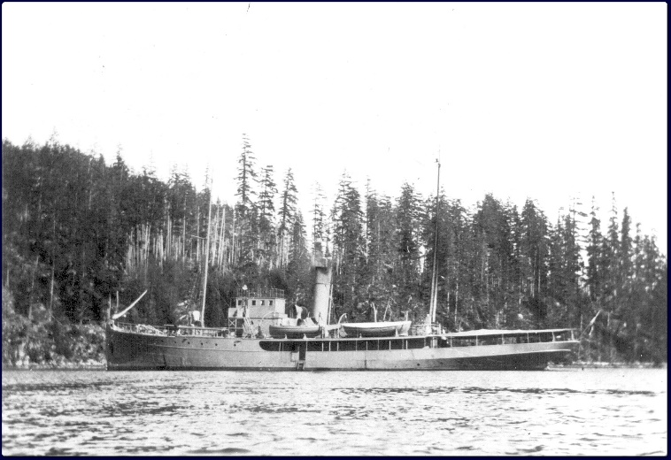

November
November 1990 Oberon Class submarine HMCS OKANAGAN visits Hamilton. Reception onboard for invited guests from STAR
1 November 1914 The Drake Class cruiser, HMS GOOD HOPE, is sunk by a German Squadron of the coast of Chile in the Battle of Coronel. Four Canadian midshipmen serving in her become the first Canadian casualties of the Great War.
1 November 1941 Hamilton Division RCNVR commissioned as HMCS STAR
2 November 1923 Hamilton Half Company RCNVR begins drills at W.W. Grant Sail Loft, 469 Bay Street at Burlington
4 November 1805 HMS PICKLE, a topsail schooner, arrives in Falmouth, England with news of the victory at Trafalgar. This is a traditional occasion for Petty Officers to hold a “Pickle Night” mess dinner

5 November 1940 Armed Merchant cruiser, HMS JERVIS BAY, armed with seven 6” guns, engages the German heavy cruiser ADMIRAL SCHEER, armed with six 11” guns and protected by a 3.1 inch armour belt. Ordinary Signalman William Hardy Danby, V-8267, RCNVR, from HMCS STAR is lost. The Captain, Fogarty-Fegen receives a posthumous Victoria Cross.

5 November 1956 Avenger 53161 was practicing landings at Brantford with an LSO and crashed and was written off
7 November 1910 HMCS RAINBOW arrives in Esquimalt
11 November 1918 Armistice ends the First World War. A total of 150 Canadian Naval personnel died on active service during the First World War.
15 November 1942 Ordinary Seaman David Oribine, V-8627, RCNVR of HMCS STAR was lost when the Troop Transport ETTRICK was torpedoed and sunk off Gibraltar by U-155, 9 Canadians among 24 lost. He had been assigned to HMS QUEBEC, RN amphibious landing training centre at Inveraray, Scotland.

17 November 1974 HMCS PORTE DAUPHINE recommissioned alongside STAR after service as a Coast Guard vessel
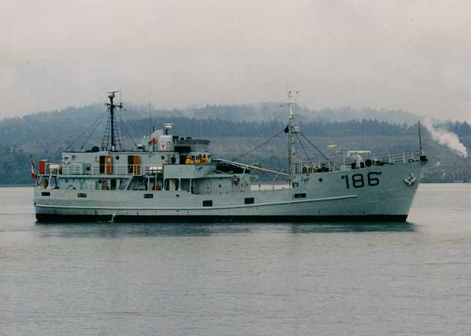
18 November 2012 former HMCS OJIBWA leaves Heddle Marine in Hamilton on her way through the Welland Canal to her new home as a museum ship in Port Burwell.
25 November 1944 HMCS SHAWINIGAN, corvette, torpedoed by U-1228 off Port aux Basques in Cabot Strait while waiting to escort the passenger ferry Burgeo, from Port aux Basques to Sydney, all 91 lost. 47-34N 59-11W
  - Stoker 1st Class John Lloyd James, V-54022, RCNVR
  - Able Seaman Hugh Lamour Todd, V-8907, RCNVR

25 November 1944 The Hamilton Wildcats are defeated 7/6 in the 32nd Grey Cup at Civic Stadium by a Naval Reserve team, HMCS DONNACONA-ST. HYACINTHE Combines
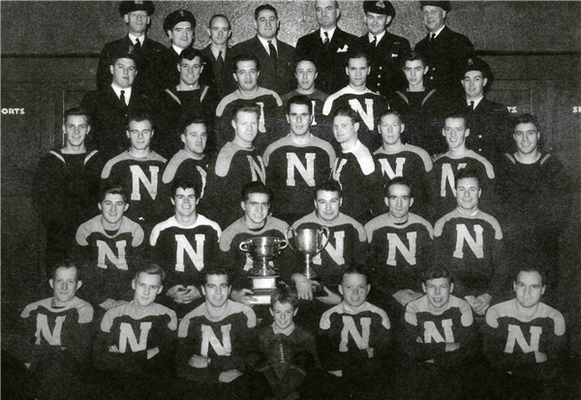
30 November 1985 STAR parades a hundred-man guard for The Honorable Lincoln Alexander, Lt Gov of Ontario, on the occasion of the opening of Copps Coliseum.

December
1 December 1940 Petty Officer Daniel Gearing from Hamilton is awarded the Distinguished Service Medal (DSM) as a result of his actions during the torpedoing of HMCS SAGUENAY by the Italian submarine ARGO 300 miles west of Ireland. “For bravery and devotion to duty before the enemy. After torpedo damage to HMCS SAGUENAYy, Petty Officer Gearing rendered exceptional services in firefighting and in effecting electrical repairs. His tenacity, efficiency and devotion to duty were of a very high order." The ship was able to make port for repairs but suffered 21 killed.

07 December 1941 HMCS WINDFLOWER, corvette, while escorting convoy SC.58, rammed & sunk by Dutch freighter SS ZYPENBURG in dense fog off the Grand Banks, 23 lost. 46-19N 49-30W
Signalman Ernest William Ayers, V-8278, RCNVR
Leading Stoker Wilbur Lamb Morris, V-8485, RCNVR

9 December 1937 A/Lt William Hugh Gregory Roger joins the Hamilton Half Company as an electrical officer. Mobilized for duty in 1938, he received the OBE for “organized and administered the Electrical Department of His Majesty's Canadian Dockyard, Halifax. His untiring efforts have contributed to the refit and repair of ships engaged in the Battle of the Atlantic." He rose to the rank of Commodore before retiring in 1953.

12 December 1942 Ordinary Signalman Hector Albert “Bart” Charles Wooley, V-8285, RCNVR of HMCS STAR was killed when a Fire broke out in the Knights of Columbus Hostel in St. John’s Newfoundland where a dance was being held. Nineteen Canadian sailors were among the ninety-nine killed.

15 December 1948 storm sinks Youville and 85’ patrol vessel (unknown) alongside. Breakwater constructed to provide more shelter for STAR basin.

16 December 1911 Ships of the Royal Canadian Navy are ordered to fly the White Ensign at the stern, the Blue Ensign at the bow as a jack and a white “Captain’s” Pennant at the masthead. All ships and vessels of the Royal Canadian Navy shall fly at the stern the White Ensign as the symbol of the authority of the Crown, and at the Jack Staff the distinctive flag of the Dominion of Canada, such distinctive flag being the Blue Ensign with the arms of the Dominion inset in the fly. The White Pendant will be flown at the Masthead. (Canadian Order-in-Council PC 2843 of December 16, 1911. Published in the Canadian Gazette on December 30, 1911.)

27 December 1942 The corvette CHILLIWACK, whose mast is on STAR’s quarterdeck, shares in the sinking of the Type VII-C U-boat, U-356, north of the Azores.
29 December 1837 During the 1837 Rebellion, a group of “Naval Militia” including some from the Hamilton area, capture and destroy William Lyon Mackenzie’s supply vessel, the CAROLINE, in the Niagara River.
31 December 1959 In 1863 the Royal Navy introduced coloured lace between the stripes on officer’s uniforms to designate the branch of service: medical officers wore scarlet, paymasters wore white and engineers wore purple. The same system was adopted by the RCN until 1959 when only medical personnel and other non-combatants continued to wear coloured lace.

